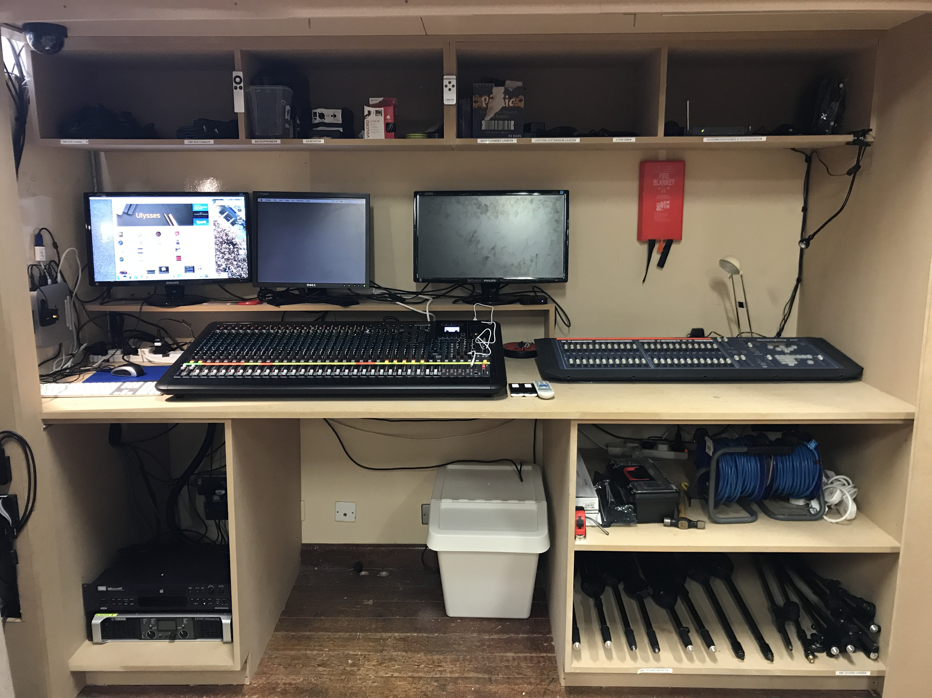

Antrim Grammar School

Sound Operation Manual

First Edition

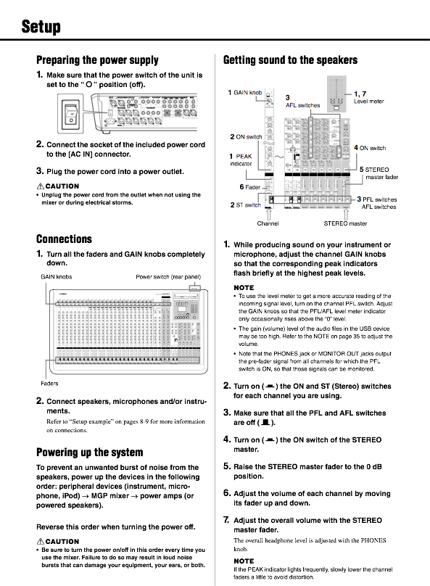

1. Open all three doors and slide them into place
2. Turn on wall switches located behind the Amplifiers (There are 6 different extension leads, we use 4 of them and the other two are used by Journey Community Church, ensure that our 4 extension leads are the 4 plugged in
3. Turn on the extension lead located on the top of sound desk - this powers the desk, monitors and Mac Mini.
4. Turn on sound desk, on switch is located on the back
5. Turn on the two Amplifiers (one amplifier for front speakers and one for back speakers) - It is vital that amplifiers are turned on after desk has been turned on, this is to avoid damaging the speakers.
6. The system is now ready to be used

**Opening and Powering On**

* 2 Lectern Microphones - Input 1 and 2
  + Aim to have their volume level between -5dB and +5dB
* Mac mini -this input is labelled as Mac Mini
  + Volume level for Mac Mini should be adjusted on a case by case basis as videos drastically alter in volume level
* Occasionally a second 3.5mm jack input is required, this is labelled 3.5mm Jack

**Assembly Sound Requirements**

* Mac mini -this input is labelled as Mac Mini
  + Volume level for Mac Mini should be adjusted on a case by case basis as songs drastically alter in volume level
* 3.5mm Jack labelled Mini Jack
* An iPhone or iPad can be plugged in using a lightening cable - labelled iPod

**P.A. Sound Requirements**

**Please see following pages for more detailed sound operation**

**For Advance Operations see Yamaha User Manual**

**Getting Sound to the Speakers**

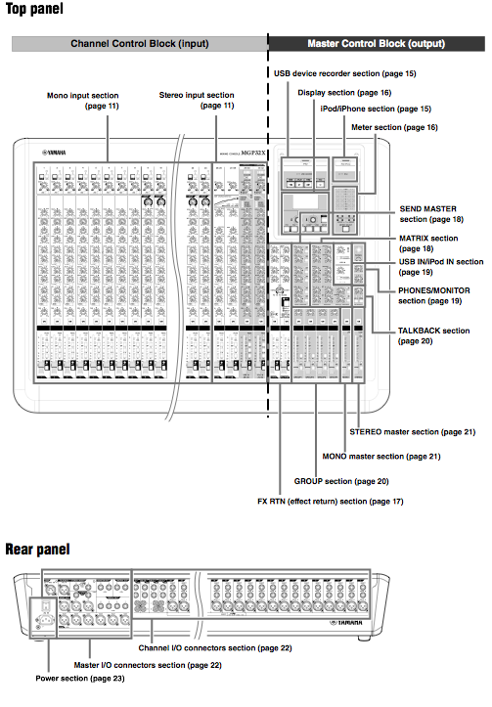

**Controls and Connectors**

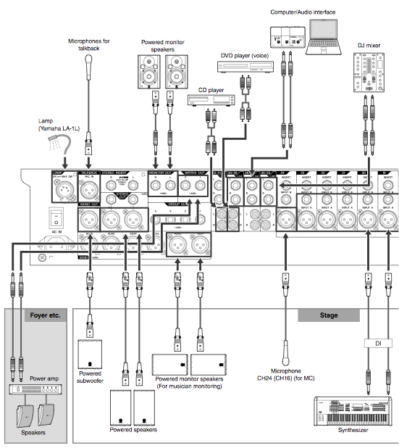

**Set Up Example**

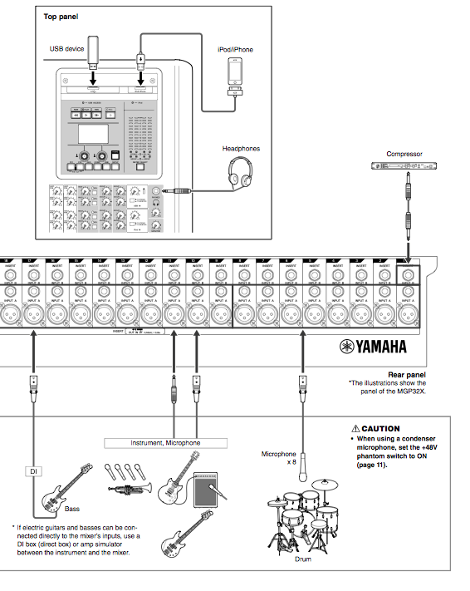

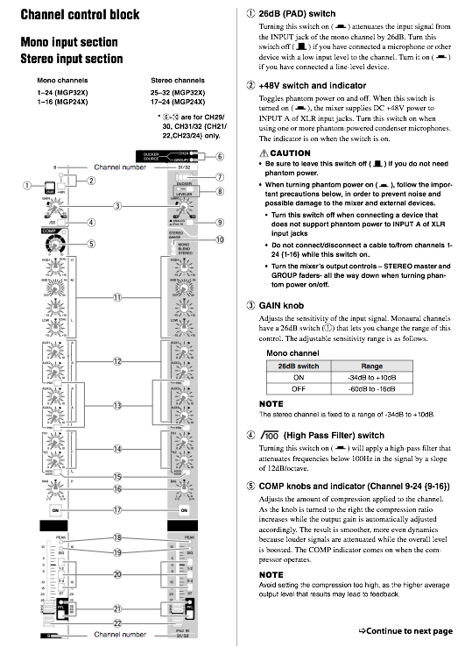

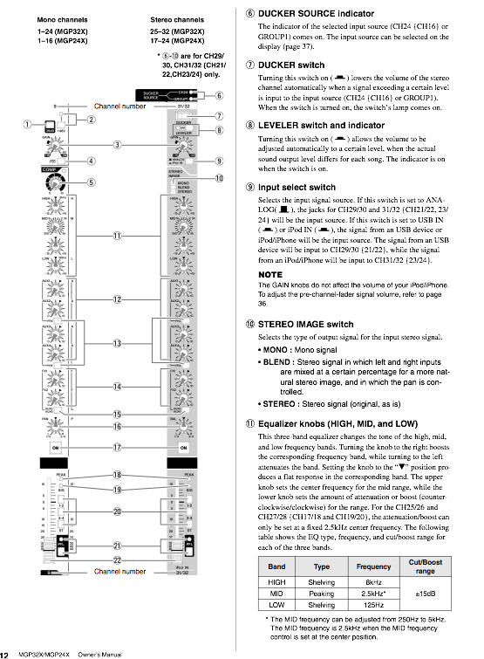

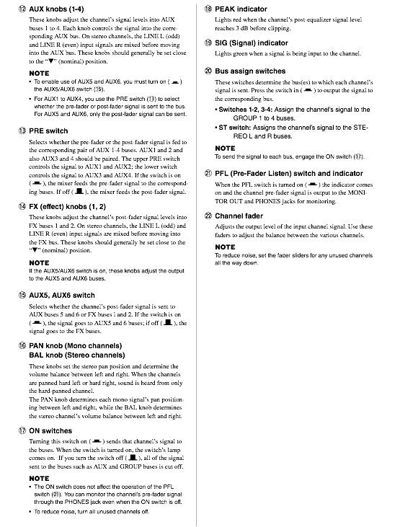

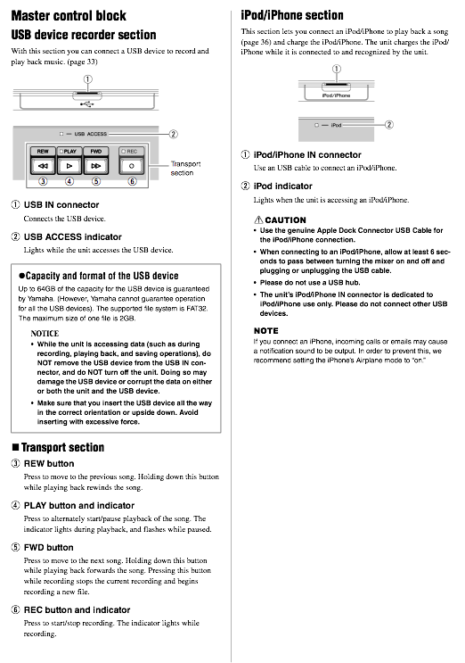

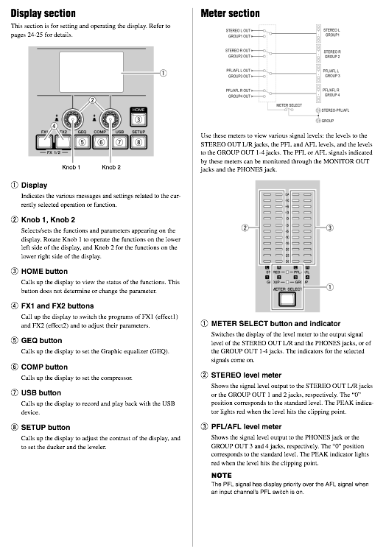

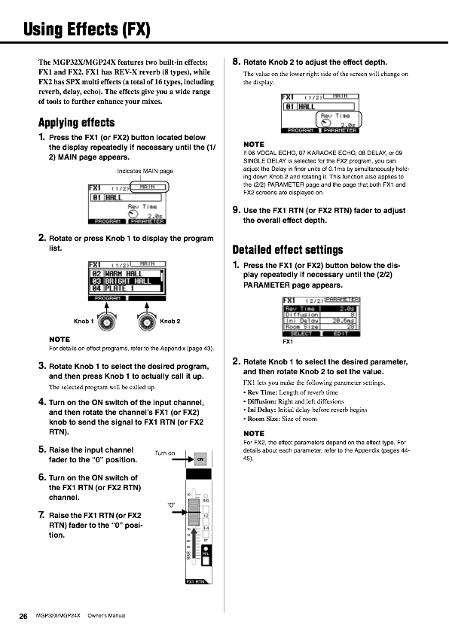

**Using Effects**

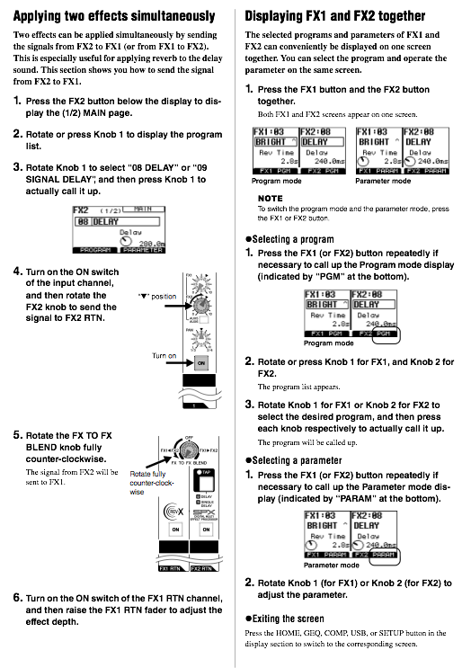

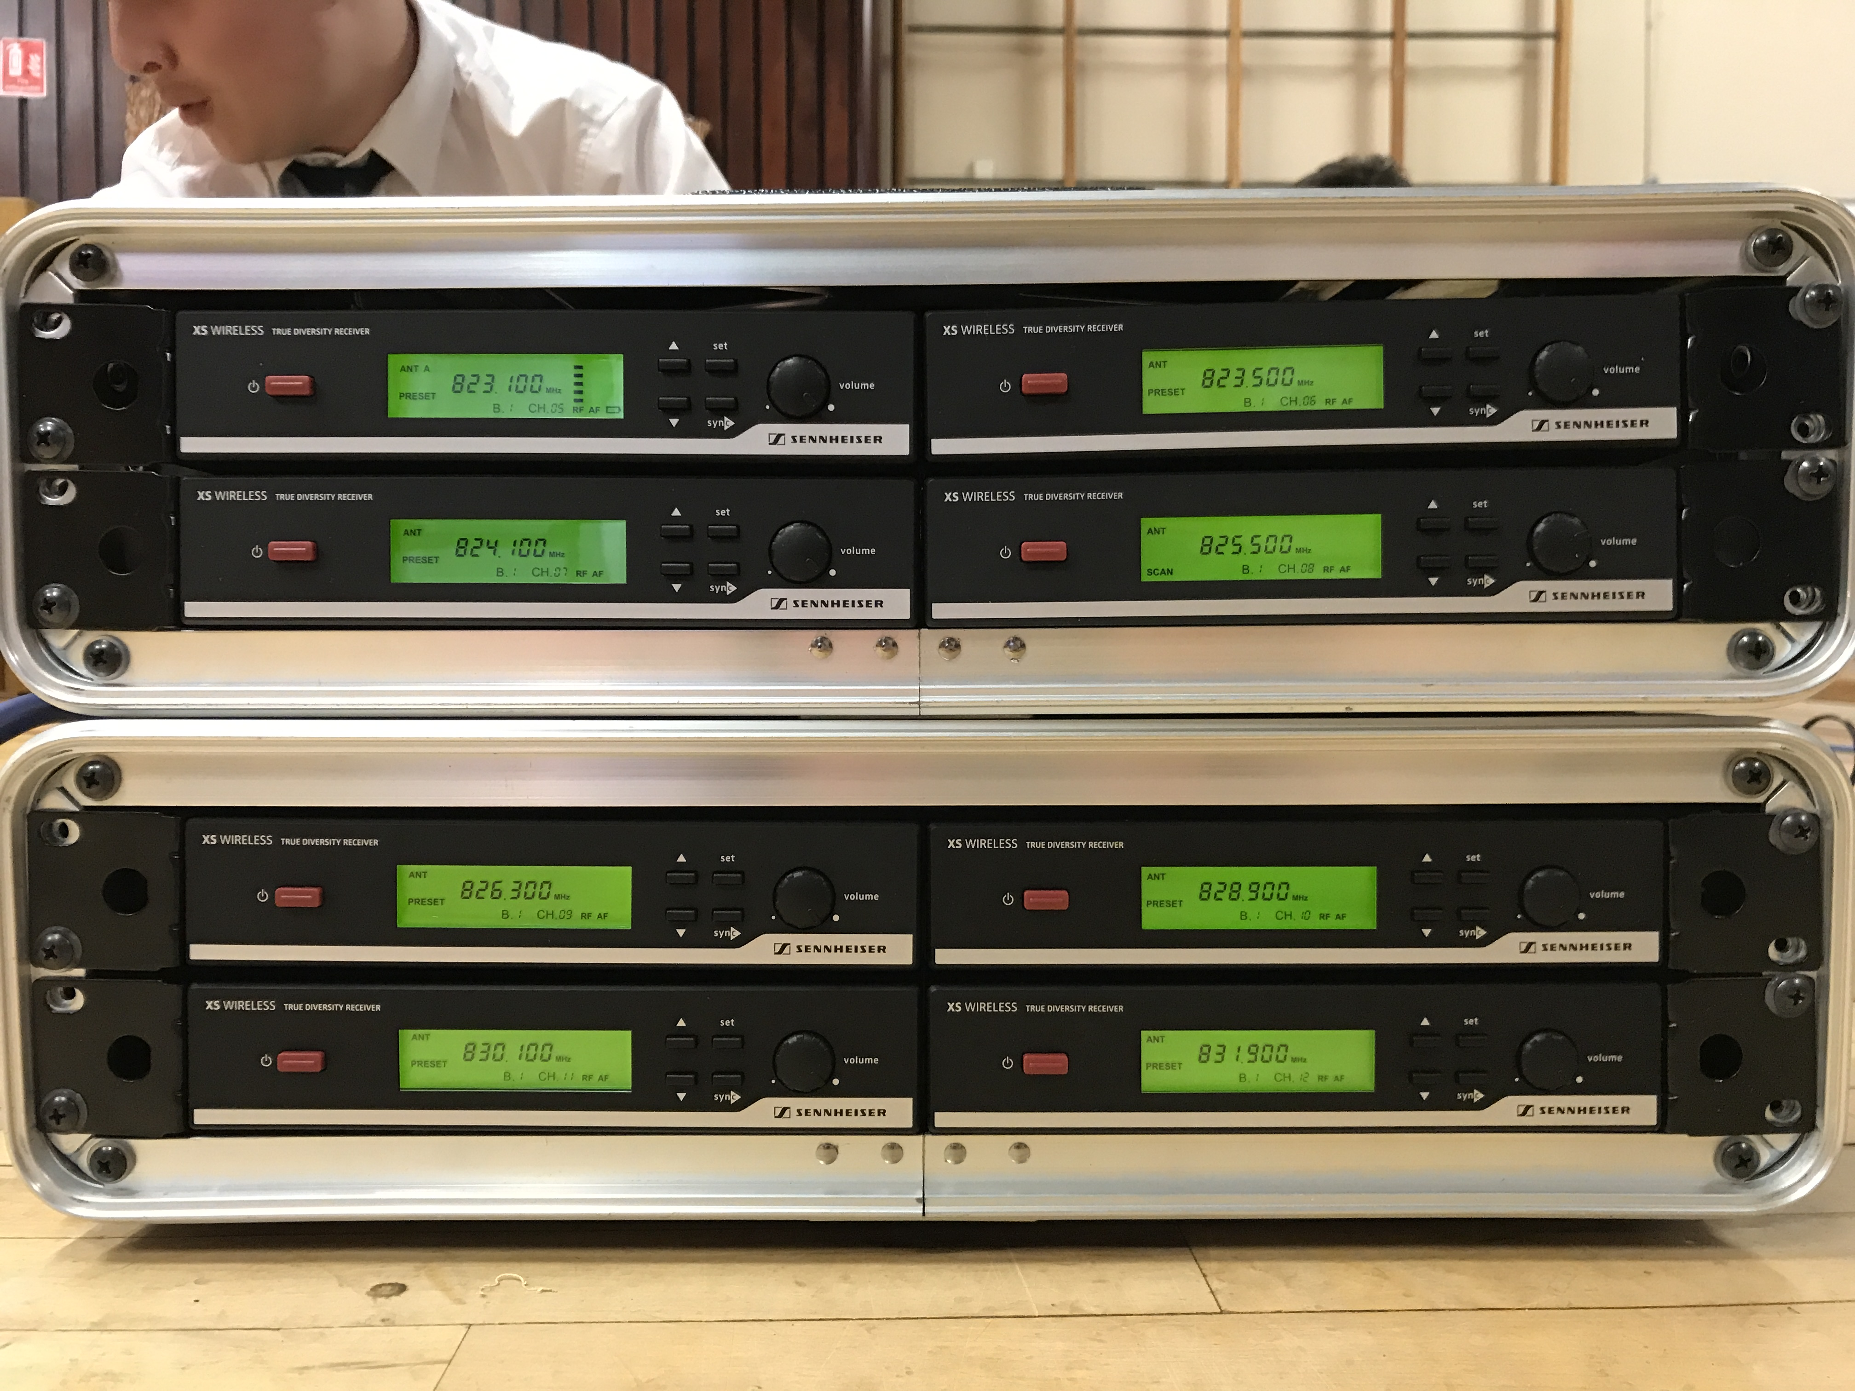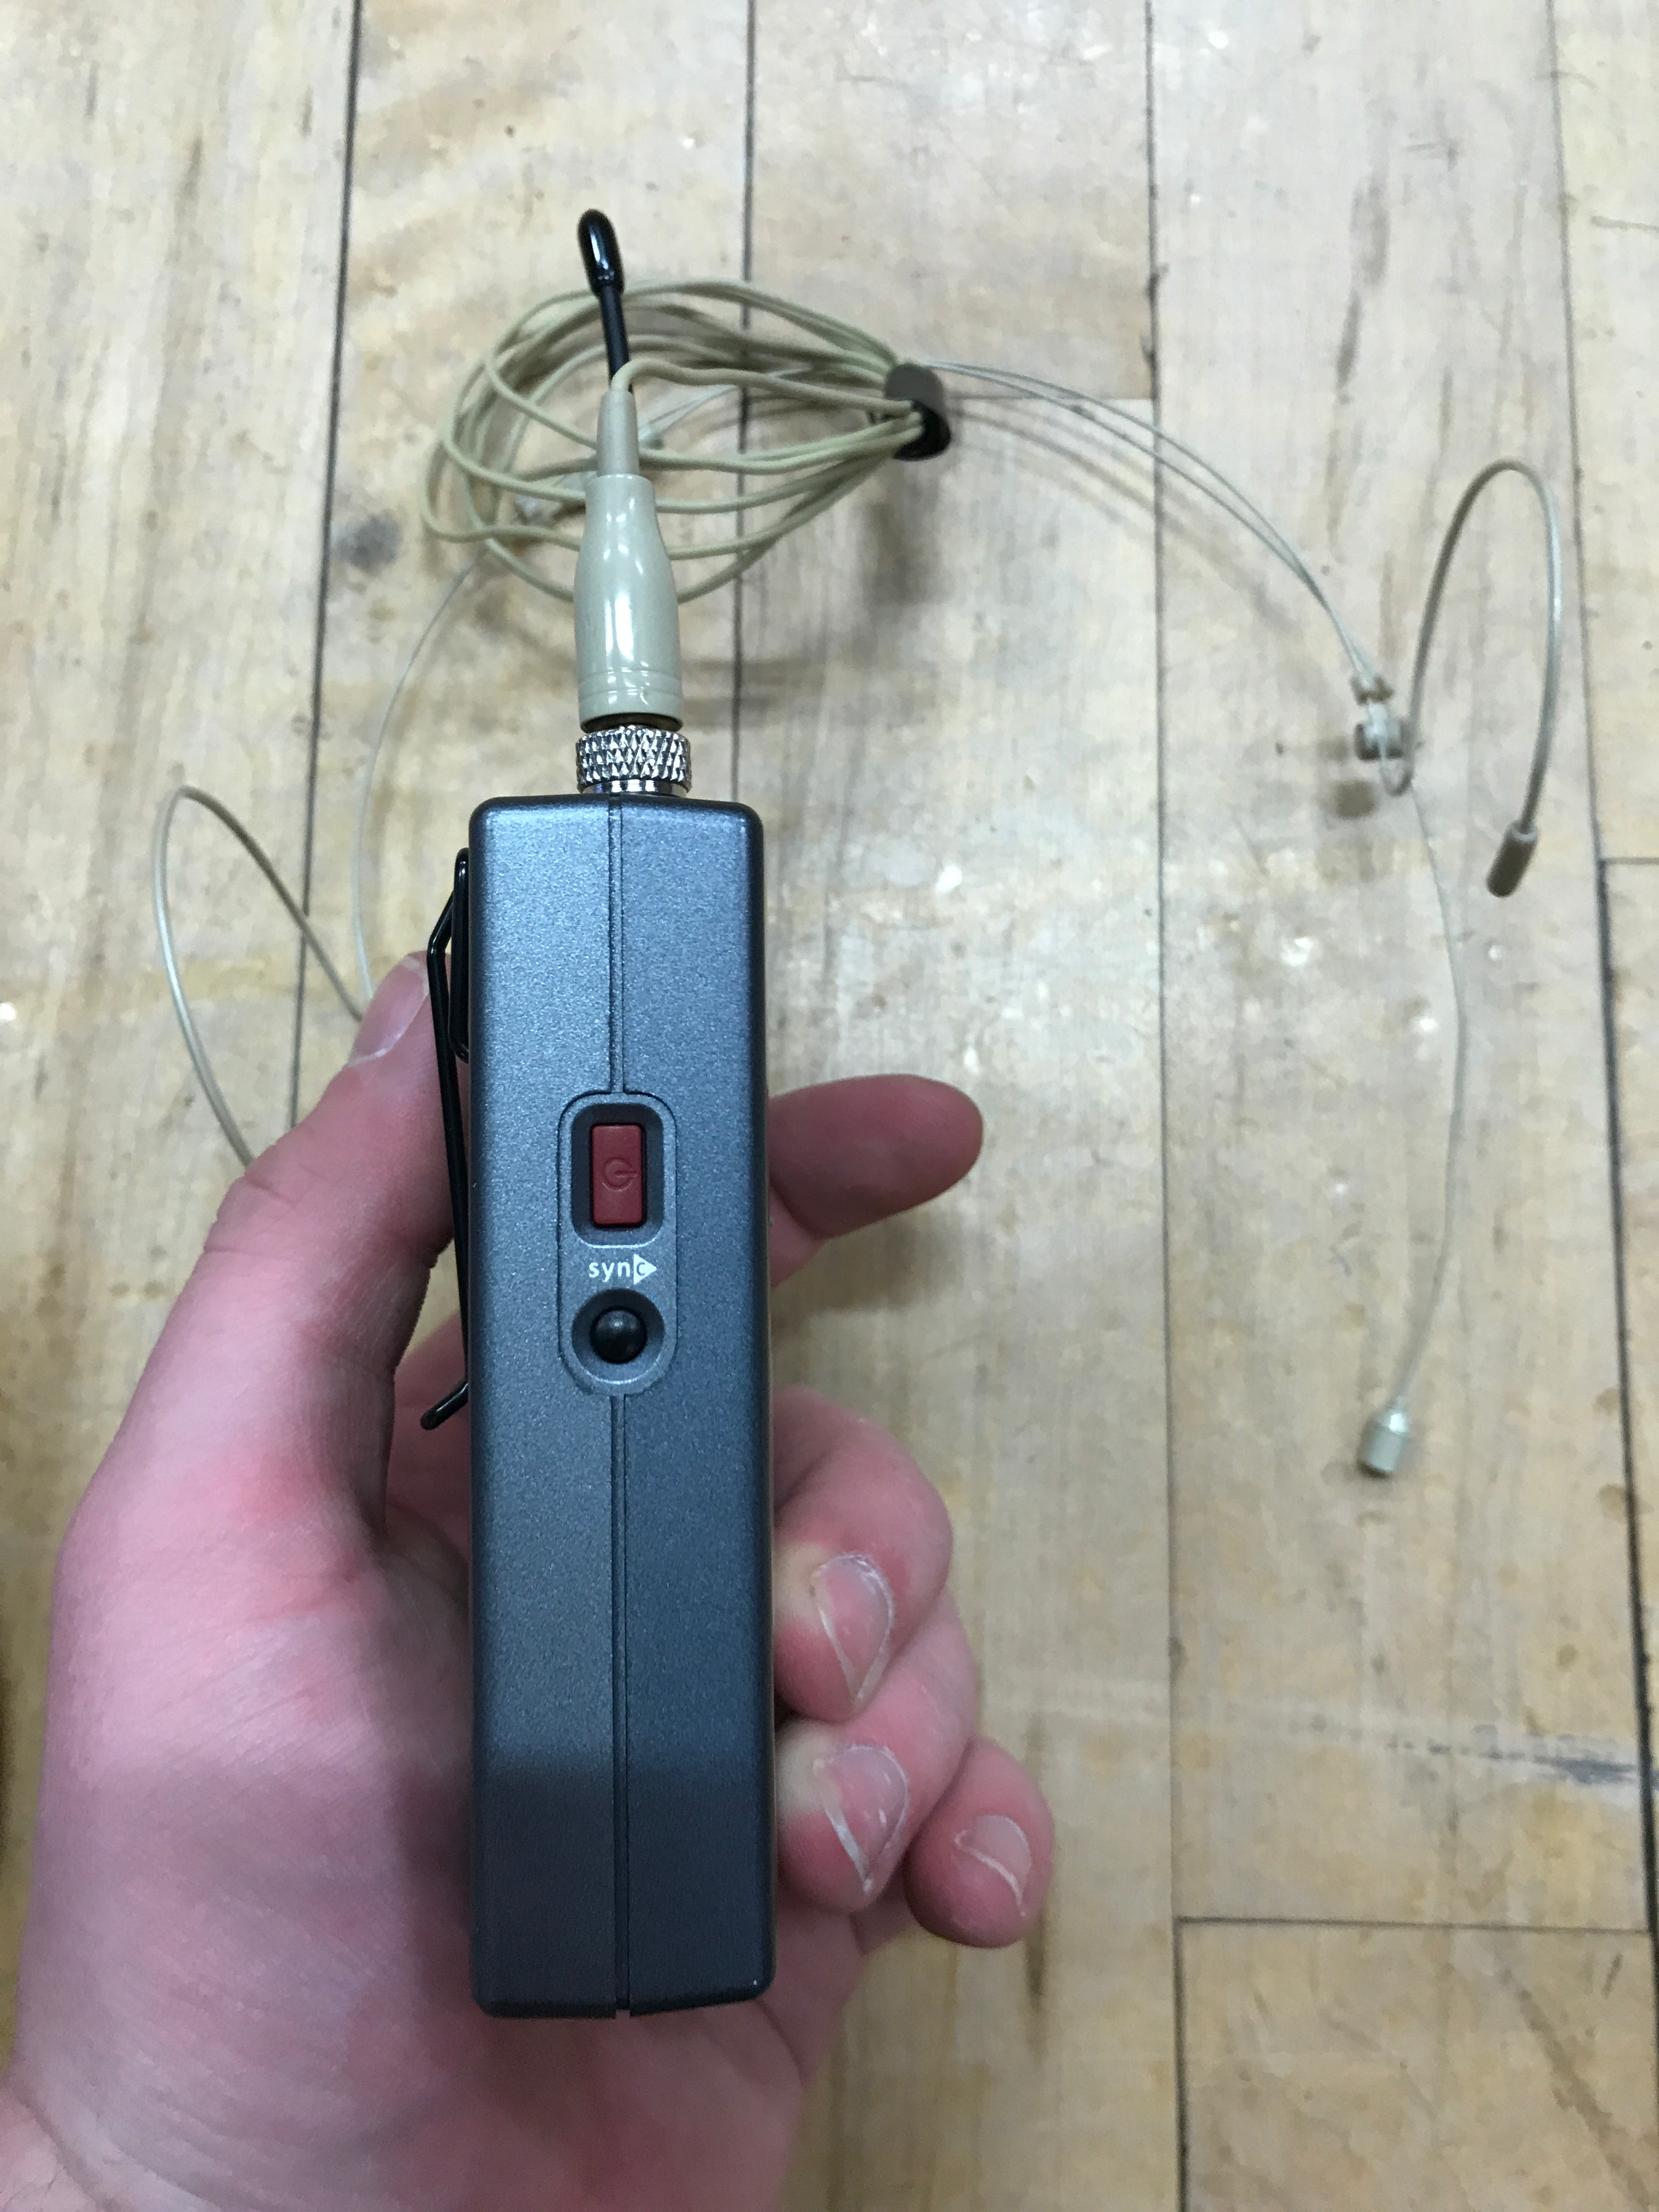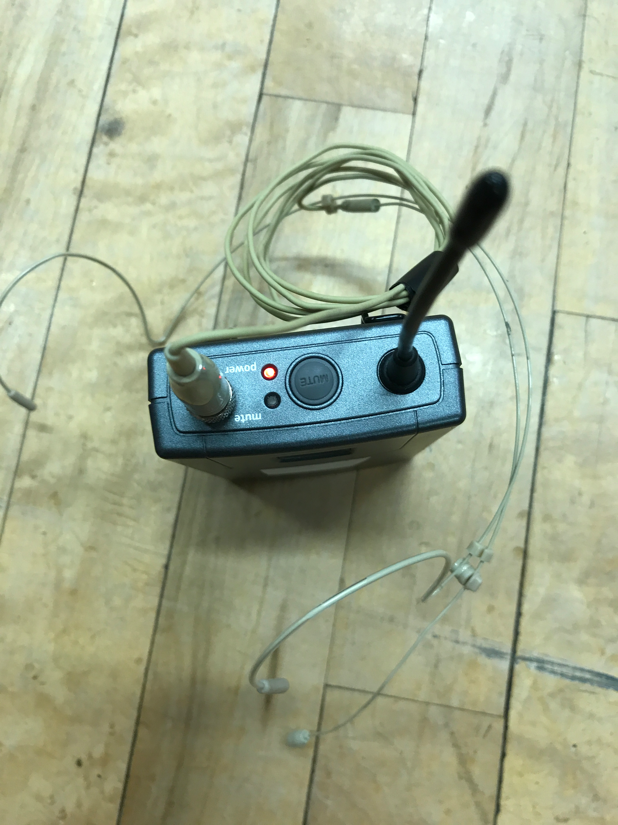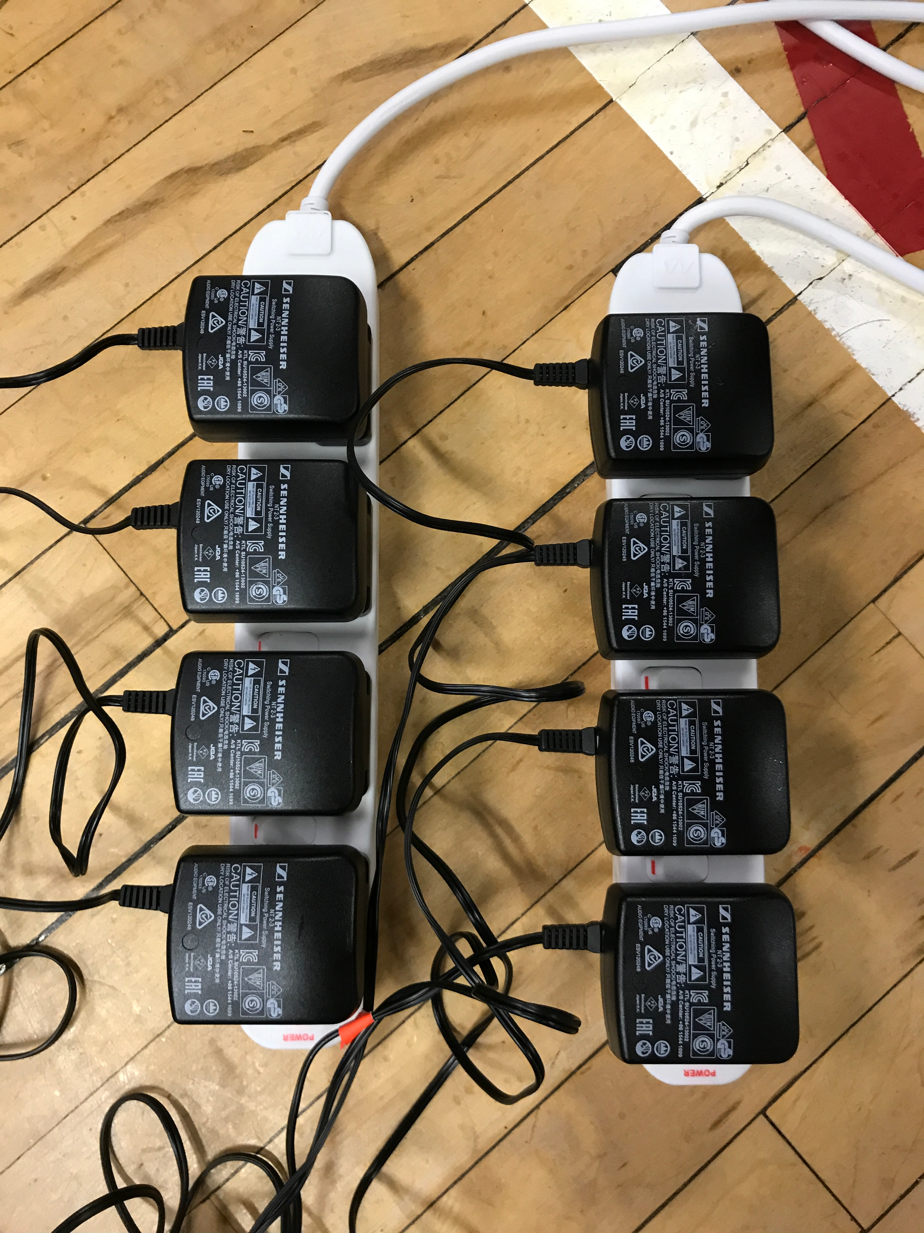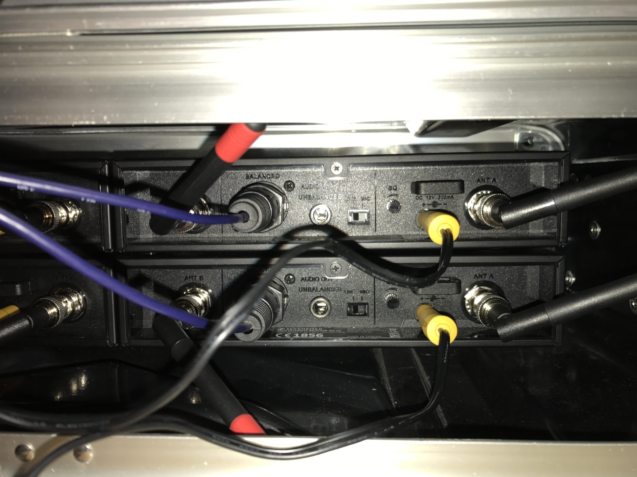

**Using Radio Microphones**

Plug power supplies into extension leads with switches

Plug 8 core XLR lead into the receivers (Match up number on core with each radio mic)

Plug power supply into receivers

Attach aerials to receivers (2 each)

Turn on receivers and belt packs

Ensure each frequency on the receivers match up with the corresponding belt pack

Attach headsets to belt packs

There is mute button on top of each belt pack - ensure this off before using belt packs

***Top tip - don’t allow actors and actresses to use mute button between acts, they always remember to put them on mute and often forget to unmute***

**Using Desk from Back**

Use 3 tables from Dr Reidy’s, one for Mac mini, one for sound desk and one for lighting desk

Plug sound desk and lighting desk into the two plugs on the back wall

Run 2 blue extension leads from the side of the hall; one for radio microphones and one for the Mac mini and screen.

There is a long VGA lead, use this for the Mac minis output

Plug DMX cable into lighting desk and swap over the DMX Cables by the demultiplexer so that the yellow tag cable is now in use

Plug multicore 1-12 into the sound desk - You will not need all of them so work out how many are needed

Plug SPEAKER 1 and SPEAKER 2 from multicore into Stero Out R and L on back of desk. Using an XLR Male to 1/4 Jack Female adapter plug in Monitor A and Monitor B in the XLR STERO Outputs on desk

Beneath the Amplifiers there are 4 colour coded jack cables - plug these into the amplifiers in the place of the cables currently in the back of the amplifiers - this has now connected the desk at the back of the hall to the amplifiers

**Concert Requirements**

**Musical Requirements**

4 Choir Microphones

Piano Mic

2 soloist mics (Use the Shure SM58 microphones)

Emergency stand by microphone

Possible a radio microphone or 2